**Sprint -3**

|  |  |
| --- | --- |
| Date | 12 November 2022 |
| Team ID | PNT2022TMID15324 |
| Project Name | Project – Smart Farmer - IoT Enabled Smart Farming Application |

MOBILE APP USING MIT APP INVENTER :

**QR CODE :**

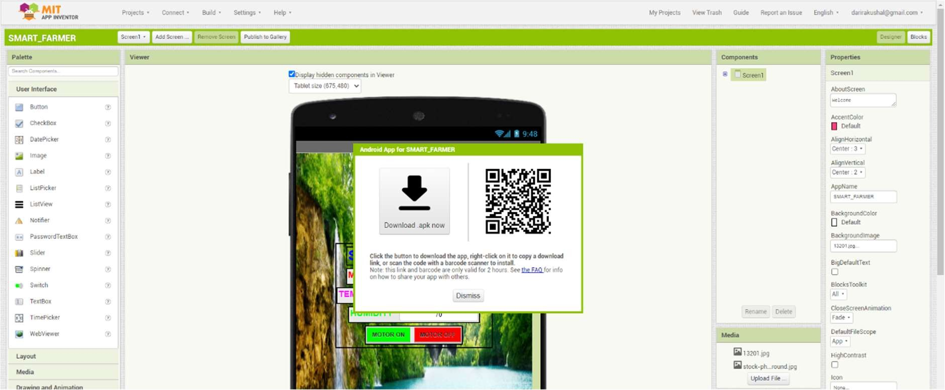

**BLOCKS :**

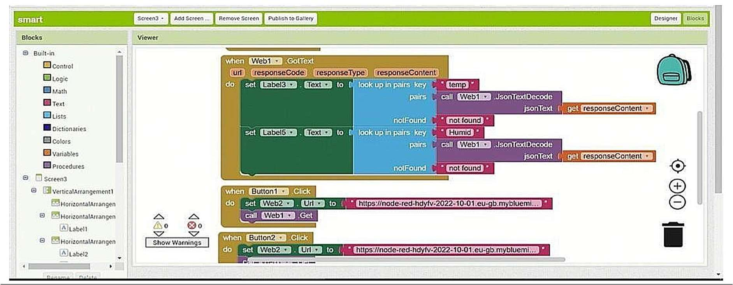

**MOBILE APP VIEW :**

